S² - Smart Signaling
A Major 1 Project Report submitted in partial fulfilment of the
requirements for the award of the degree of

BACHELOR OF TECHNOLOGY
in

COMPUTER SCIENCE AND ENGINEERING
with IBM specialization in CYBER SECURITY AND FORENSICS

Submitted by
DHANISHTHA AWASTHI | R134215026 | 500046214 | CSE-CSF | 7th Sem
KUNAL MOHAN BANSAL | R134215039 | 500046496 | CSE-CSF | 7th Sem
SHUBHAM KUMAR GUPTA | R134215077 | 500045997 | CSE-CSF | 7th Sem

Under the guidance of

Dr. Ajay Prasad
Cyber Platform
SCS


SCHOOL OF COMPUTER SCIENCE
UNIVERSITY OF PETROLEUM & ENERGY STUDIES
November - 2018.
Approved By
Dr. Ajay Prasad Dr. Neelu Jyoti Ahuja
Project Head Head of Department
DECLARATION

I hereby declare that this submission is my own and that, to the best of my knowledge and belief, it contains no material previously published or written by another person nor material which has been accepted for the award of any other Degree or Diploma of the University or other Institute of Higher learning, except where due acknowledgement has been made in the text.

Dhanishtha Awasthi (Enroll No. R134215026)

Kunal Mohan Bansal (Enroll No. R134215039)

Shubham Kumar Gupta (Enroll No. R134215077)
CERTIFICATE

This is to certify that the project titled S²- Smart Signaling submitted by Dhanishtha Awasthi (Enroll. No. R134215026), Kunal Mohan Bansal (Enroll. No. R134215039), Shubham Kumar Gupta (Enroll. No. R134215077) to the University of Petroleum & Energy Studies, for the award of the degree of BACHELOR OF TECHNOLOGY in COMPUTER SCIENCE AND ENGINEERING is a Bona fide record of project work carried out by them under my supervision and guidance. The content of the project, in full or parts have not been submitted to any other Institute or University for the award of any other degree or diploma.

Date: 28th November, 2018.

Dr. Ajay Prasad Dr. Neelu Jyoti Ahuja
Mentor Head of Department
Cyber Platform | SCS Dept. of Systematics |SCS

ACKNOWLEDGEMENT

I would like to show my sincere gratitude to my supervisors Dr. Neelu Jyoti Ahuja & Dr. Ajay Prasad for providing me invaluable guidance, comments and suggestions throughout the course of the project. I would like to especially thanks Christalin Nelson sir for constantly motivating me throughout my work.
This report would not have been possible without their constant support. Also, I would like to thank University of Petroleum and Energy Studies for providing me the platform and facilities, along with the opportunity to work on this project.
Finally, I would like to thank my family and friends for their understanding and support while completing this project.

ABSTRACT

India is a developing country. Time is an essential resource for development of nation. Unfortunately, millions of people waste hours of their precious time in traffic. There are many reasons for poor traffic management. One such reason is operation of traffic lights being static instead of being adaptive difference of traffic between lanes it is responsible for. This causes green signal for empty lane and red signal for filled one, most of the times.
In this Project we will tackle this issue and will try to make a smart signal which will decide by itself on the basis of data set whether to show green or red signal to a particular lane.
The main purpose of our project is the traffic congestion control, so as to save the precious time of the people stuck in traffic.
The project deals with the Machine Learning algorithm for the decision of the amount of time for which the signal must be green or red for the particular traffic light post on the cross.
The camera on the post will be connected to the server and will capture the photograph of the road and do the background subtraction, so as to finally get the amount of congestion in the traffic. Then the calculation for the amount of time for which the signal must be green will be fed as data set of if-else conditions, resulting to the learning by self, using the machine learning approach.

Keywords: Traffic, smart signal, machine learning.
Table of Contents

Chapter 1: INTRODUCTION 5
Background of the project 5
Market Dynamics: 5
Technology: 5
Users: 5
Chapter 2: PROBLEM STATEMENT 6
Chapter 3: LITERATURE REVIEW 7
Chapter 4: OBJECTIVES 8
Chapter 5: DESIGN 9
Algorithms used 9
Machine learning Algorithm 9
Image Analytics Algorithm 9
Data Set Collection Algorithm: 9
Server connection Algorithm: 10
Prerequisites: 12
Chapter 6: IMPLEMENTATION 13
Module 1: 13
Module 2: 13
Module 3: 14
Post Module 14
Future Enhancements: 14
Output Screens: 15
Chapter 7: SYSTEM REQUIREMENTS 18
Software Requirements: 18
Hardware Requirements: 18
Chapter 8: SCHEDULE 18
Chapter 9: CONCLUSIONS 19
Chapter 10: REFERENCES 20
Appendix A: 21
Server.java 21
TCounter.java 22
T1.java 24
TL2.java 25
TL3.java 27
TL4.java 28

LIST OF TABLES
Table 1 Pert Chart 18

LIST OF FIGURES
Fig 5. 1 Flow Chart 10
Fig 5. 2 Use case diagram Error! Bookmark not defined.
Fig 5. 3 Traffic light post with camera. 12

Fig 6. 1 Background Subtraction 13
Fig 6. 2 Server is started 15
Fig 6. 3 T1 / T2 / T3 / T4 are started one by one 15
Fig 6. 4 TL4 green one at a time at interval send by server (TL4 ,22 secs) 16
Fig 6. 5 TL3 change in duration from 5 sec to 22 according to foreground mask 16
Fig 6. 6 Background subtraction done by processImage method of TCounter class 16
Fig 6. 7 TL change in time (46 secs, TL3) 17

Chapter 1

INTRODUCTION

Background of the project

Delhi, the national capital region and the most important among all, is facing a vast issue related to traffic signaling system [2]. According to the traffic lightning protocol, the controller shows red light to lanes for a certain interval of time and thus makes it difficult for the people to communicate daily to their destinations if in the case the road is empty though the light is green for that lane and the one filled more than half has still red light. This issue is detected and reported to the government which is continuous procession of finding the solution.

Market Dynamics

The project is made in hue of finding solution to a governmental problem which may proof beneficial to not only Delhi but other states of India too. Thus may make huge market value not only in India but in foreign too.
So, serving as a foundation for becoming a fast and productive country.

Technology
Machine learning and Open CV are the two major approaches nowadays for the smart development. The above stated approaches when combined with JAVA will result into the maximum profitable approach. Our project comprises of the implementation of these techniques and so the major goal of our project to make the traffic signaling system smart becomes easier.

Users
The main users of our project will be not only the people of a particular state, but can be from anywhere within the country. If used by other nations too, the traffic control would become much easier. The smartness of the system will help the people appointed on duty on crosses by relieving them from pressure of unnecessary nuisance created by people around them to give them green signal being getting late for their work in jams.

Chapter 2

PROBLEM STATEMENT

Design a smart solution to meet one of the main issues for traffic jams i.e. static nature of traffic signals which are unable to differentiate between 0 and 100% traffic. This solution should also include capabilities for central server to hold control in case of emergency or a rare event. Central server must be able to change traffic light at any time.

Chapter 3

LITERATURE REVIEW

- Smart traffic light control system. [1] is the white paper published in 2016, denoting an IR system and microcontroller-based solution to give basic. Currently no such system exists in India and is the need of the hour to build so.
- Smart Traffic Light System (IoT) [3] is the GitHub project based on the IOT approach for the signal sensing systems.
- Smart Traffic Signal [4] Traditional traffic signal system only gives instructions to stop and not to vehicle driver. But if someone is breaking the signal then this system is not able to catch them and there are chances of taking bribe. Thus, to increase the security of traffic signal and to reduce human efforts and to avoid the bribery we are introducing smart traffic signal system through this MINI PROJECT.

None of the above stated projects developed so far were able to generate the central server through which the traffic must be detected and congestion might be controlled, and so our project will deal with making of the traffic signals smart in themselves instead of using any extra external hardware system such as IOT devices and others.

Chapter 4

OBJECTIVES

- The main objective of our research and development for this project is to build an intelligent and smart traffic light signaling software.
- Also, we need to design a solution that would proof itself as not only a solution to requirement design but to requirement perceptions too.
- In this project, designing an intelligent traffic control system by studying traffic light configurations and signaling protocols will be the main motive throughout the designing of the solution.
- The machine learning approach will be inhibited and integrated while exploring the solutions to the problem statement and reaching to the conclusion with the effective one.
- The outcome must be fully or partially able to resolve traffic congestion problem because of static lightning technologies.
- The large datasets will be incorporated to reach the maximum precision level of the outcome and working of the project.
- Background subtraction will help in getting the amount of traffic on the road whose image is captured.

Chapter 5

DESIGN

Algorithms used
- Machine Learning.
- Image Analytics
- Data Set Collection.
- Server connection.

Machine learning Algorithm
Step 1: Get the amount of congestion being calculated for the traffic on a road.
Step 2: Using the if-else statement-based data set calculate the amount of time for which signal must be green.
Step 3: Self-learn for the next time i.e. if only 7 secs are required for two cars to pass then from next time the time allotted must be equal to 7 secs + All the red time. If the vehicles are able to be passed before these 7 secs then next time allotted time must be 7 secs.
Image Analytics Algorithm
Step 1: Capture an image in open CV with java using camera.
Step 2: Apply the background subtraction mechanism using contour detection technique.

Data Set Collection Algorithm
Step 1: Categorize images data using if-else statement i.e. if <20% then 10secs, if <30% then 15 secs, and so on be the time allocated.

Server Connection Algorithm

Step 1: Enable socket connection with various ports open for the traffic signaling system of the central server.

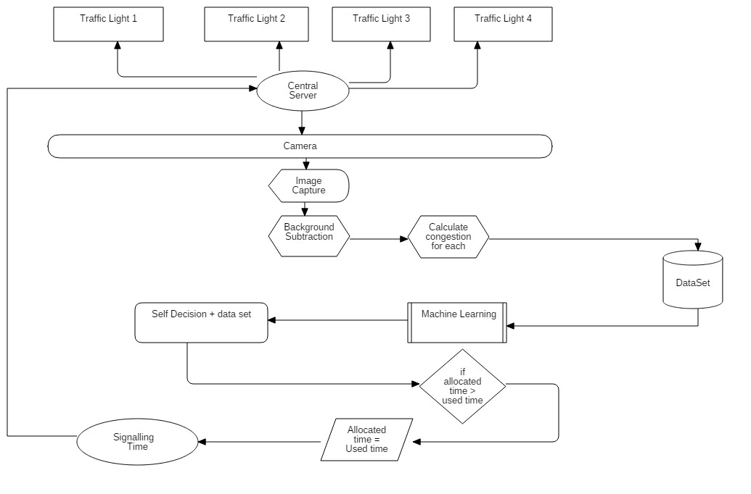b
Fig 5.1 Flow Chart
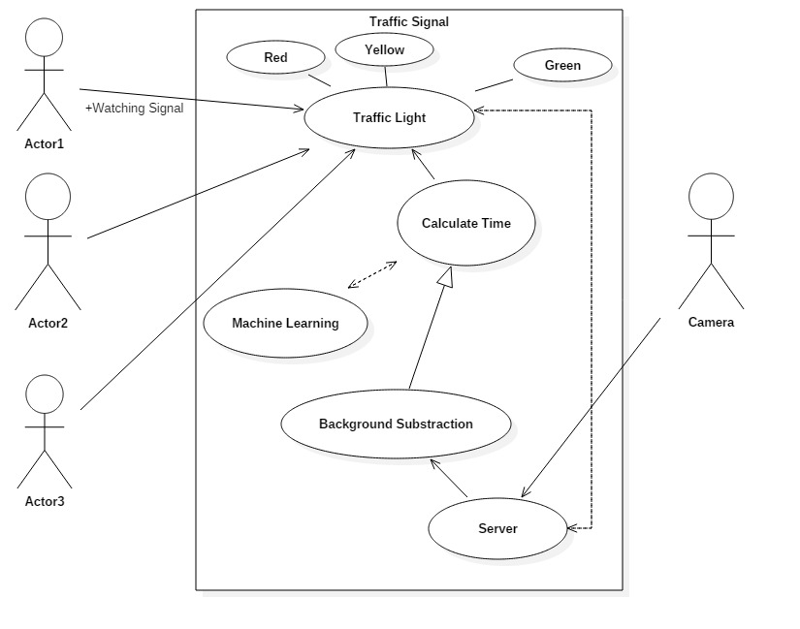
Fig 5.2 Use case diagram

Prerequisites:
- The Camera captured image from continuous video.
- Cross road signaling system data set.
- Data collection of Signal phases and cycles.
- The timings of yellow signal and all red time.
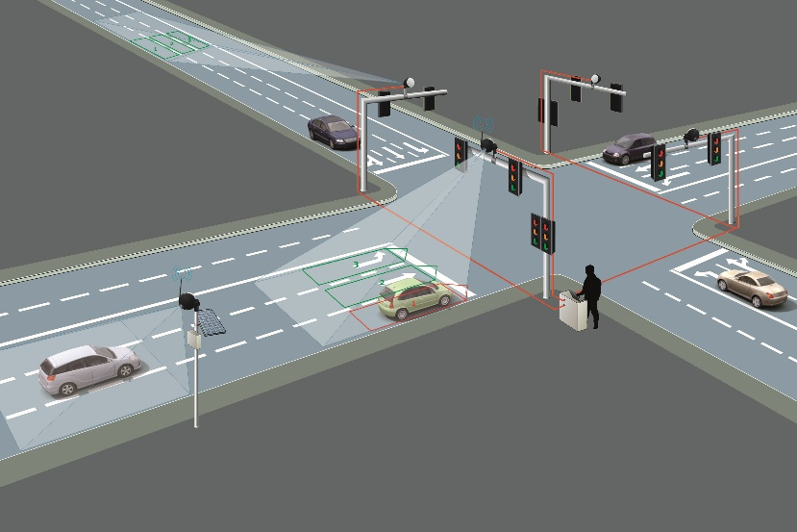
Fig 5.3 traffic light post with camera.

Chapter 6

IMPLEMENTATION

Our Project is basically divided into two main modules
Module 1
For the traffic lights to get the signal, the Server will be started. The start of Server will mark the opening of 4 ports namely –
- 6061
- 6062
- 6063
- 6064 and the ports will be used for four different Traffic lights for cross on roads.

Module 2
The second module is the Background Subtraction approach where using the camera, background subtraction will occur. The background subtraction algorithm will help us finding the appropriate amount of time for which the signal must be green.
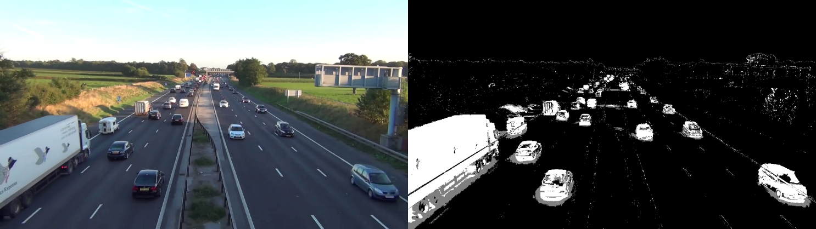
Fig 6.1 Background Subtraction

Module 3
The third and last module is the Machine learning module, where the analytics will be provided for the time calculation and green light signaling sequence.

Post Module
Now the three rules need to be followed
- No two traffic lights should be green simultaneously.
- The Machine learning should understand by itself that if previously time for two vehicles to cross was allotted to be 10secs but they used only 7secs next time it should try for 7secs and learn by self in the process.
- There should be yellow light and all red time kept in mind before next port to generate a green signal to prevent vehicle collision.

Future Enhancements
The future enhancement for this project will include, certain analytics, improved background subtraction, implementation through Proof of Concept using 3D camera or 4 different cameras, on real time systems.

Output Screens
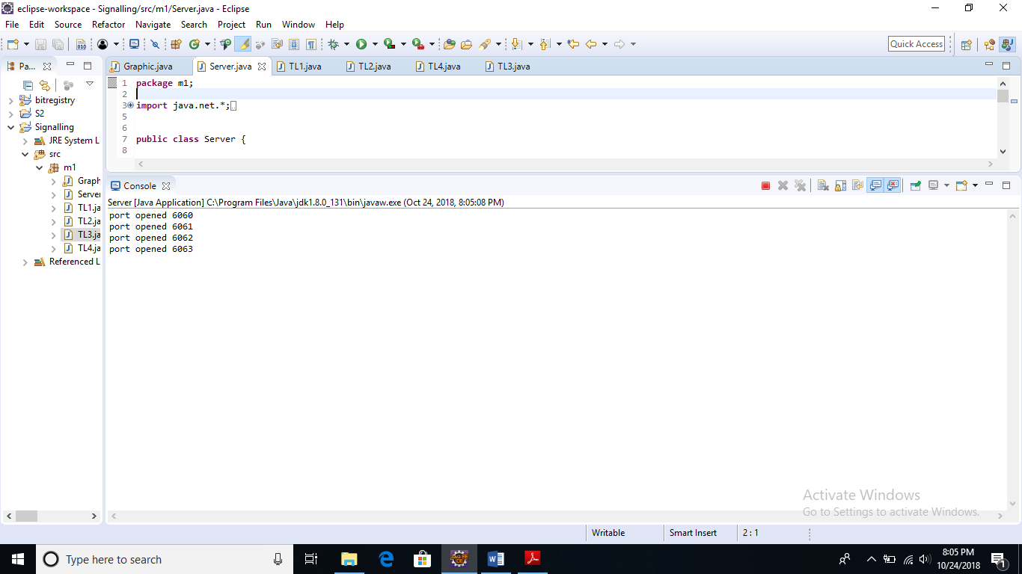
Fig 6.2 Server is started

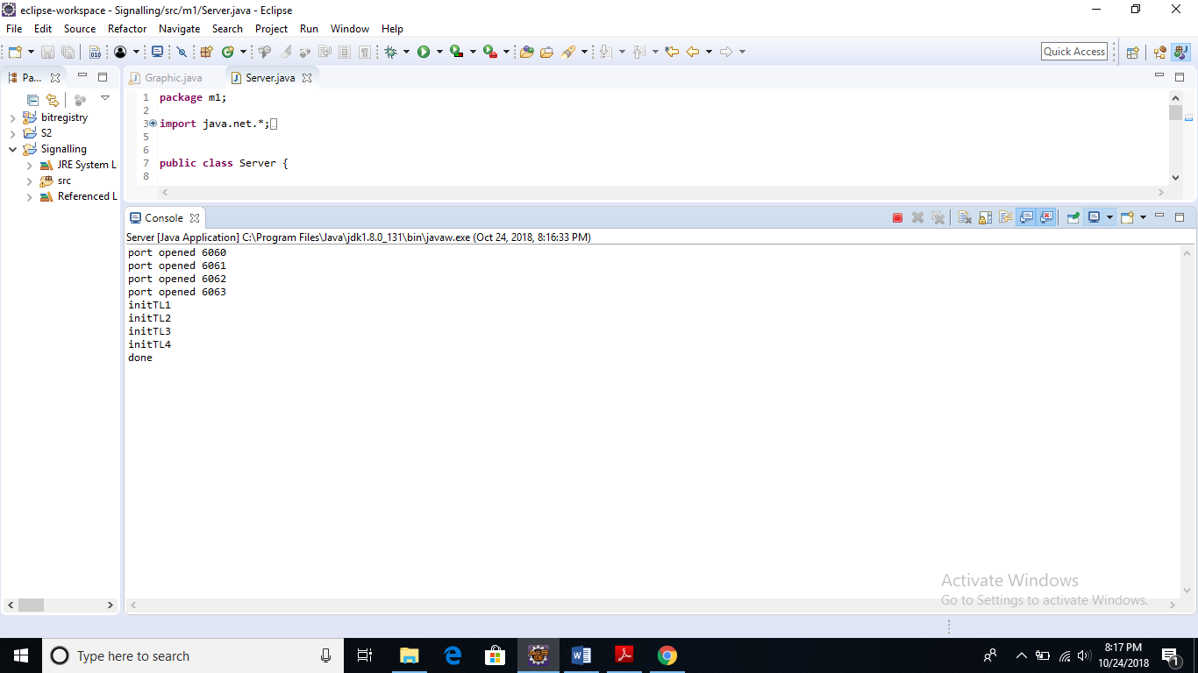
Fig 6.3 T1 / T2 / T3 / T4 are started one by one

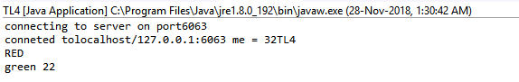
Fig 6.4 tl4 green at a time at interval send by server (TL4 ,22 secs)

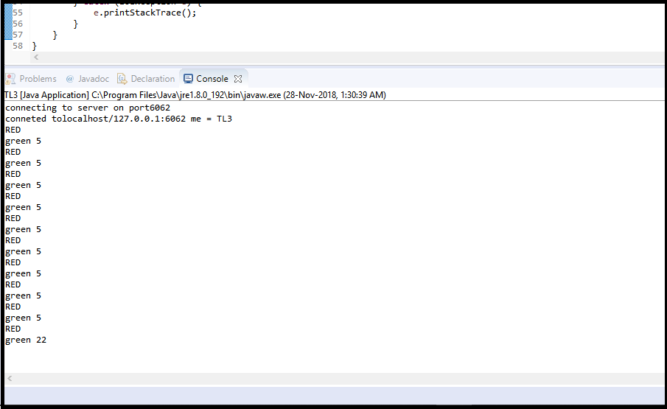
Fig 6.5 TL3 change in duration from 5 sec to 22 according to foreground mask

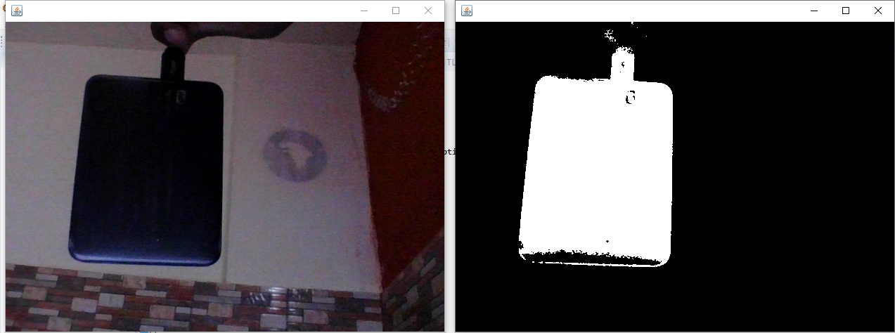
Fig 6.6 Background subtraction done by processFrame method of TCounter class

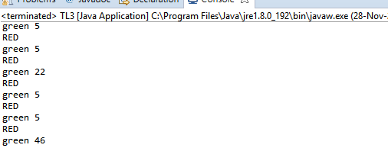
Fig 6.7 : TL change in time (46 secs, TL3)

Chapter 7

SYSTEM REQUIREMENTS

Software Requirements:
      - Eclipse
      - Open CV
      - Java

Hardware Requirements:
- Minimum requirements and configuration support.

Chapter 8

SCHEDULE

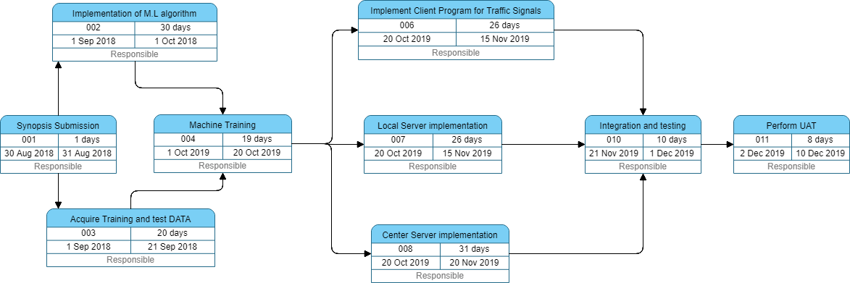

Table 1 Pert Chart

Chapter 9

CONCLUSIONS

At last, we would like to conclude our project by simply claiming that we were successful in delivering the intended results and achieving the objectives laid at the start of our project. This project will simply proof itself in decreasing the congestion in the traffic on the crosses. This project will proof itself valuable for not only Indian Government but also inter-nation-wide.

Chapter 10

REFERENCES

[1] Conference Paper (PDF Available) · April 2016 with 23,706 Reads
DOI: 10.1109/EECEA.2016.7470780
Conference: Conference: 2016 Third International Conference on Electrical, Electronics, Computer Engineering and their Applications (EECEA)
.
[2] https://timesofindia.indiatimes.com/city/delhi/10-years-on-plan-to-use-ai-to-manage-city-traffic-takes-off/articleshow/63495347.cms

[3] https://github.com/salamzantout/Smart-Traffic-Light

[4] https://www.researchgate.net/publication/262941886_Smart_Traffic_Signal

Appendix A
Code Snippets

Server.java
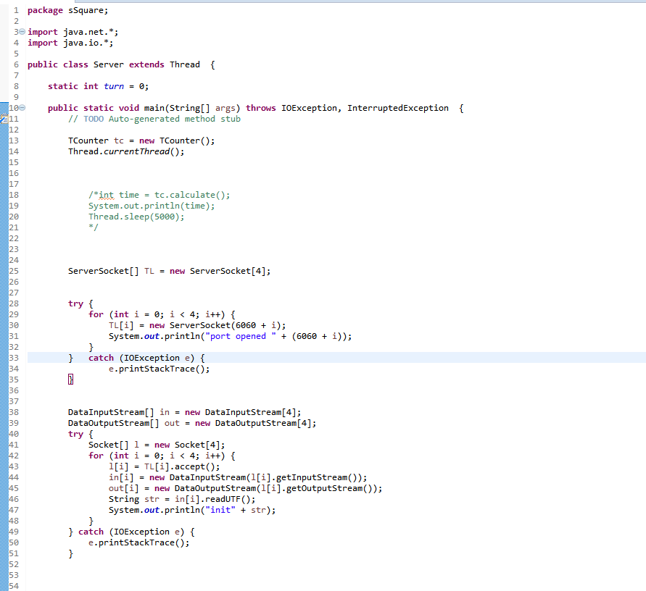
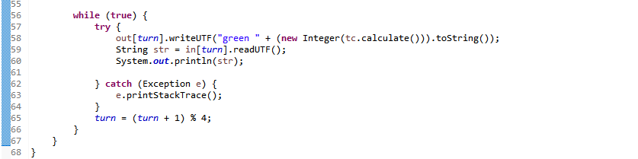

TCounter.java
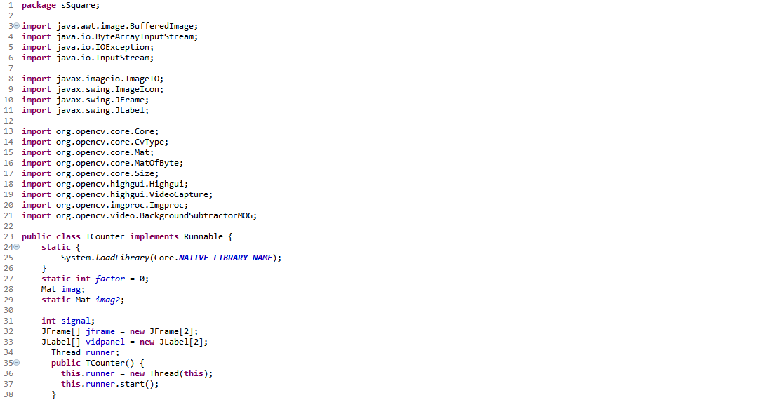
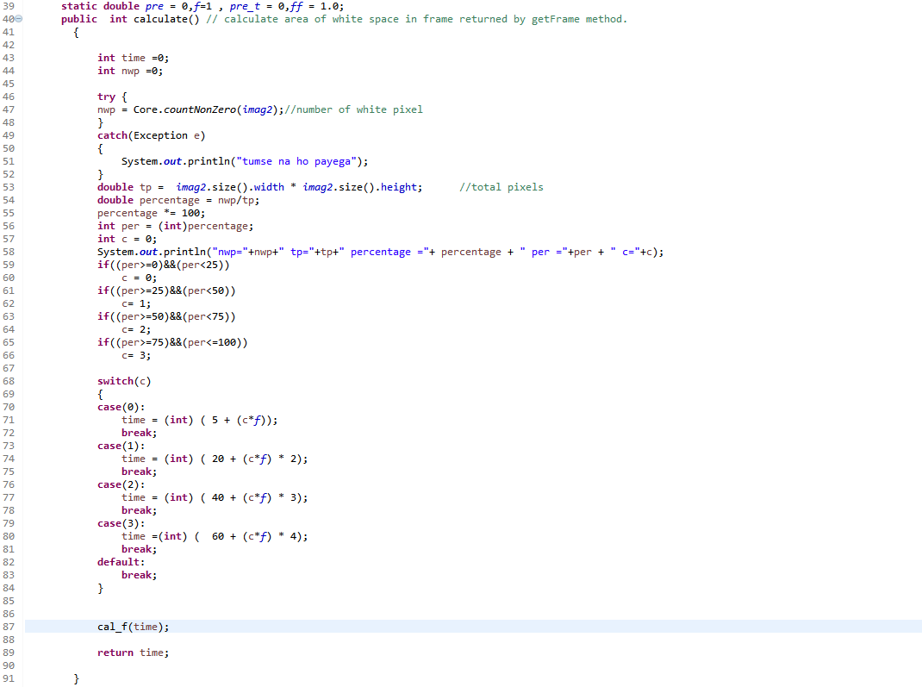
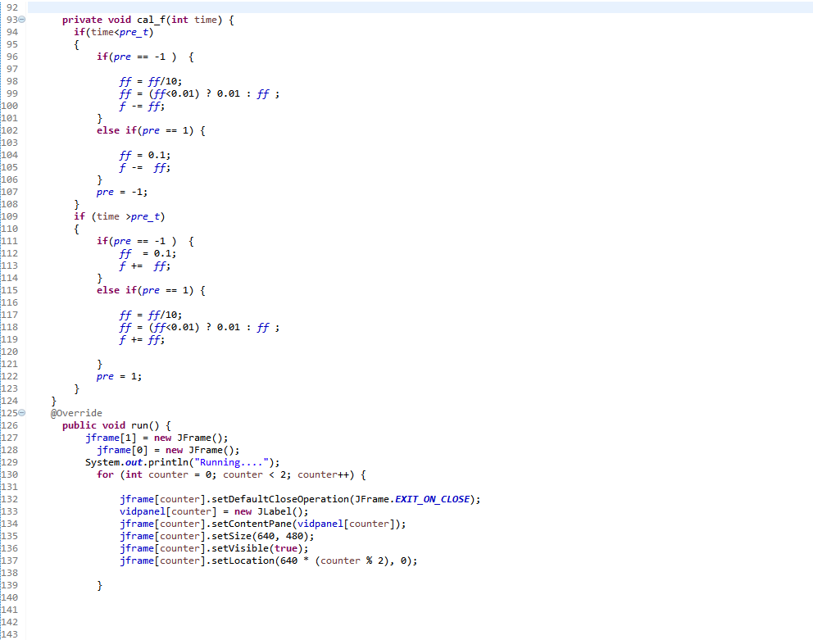
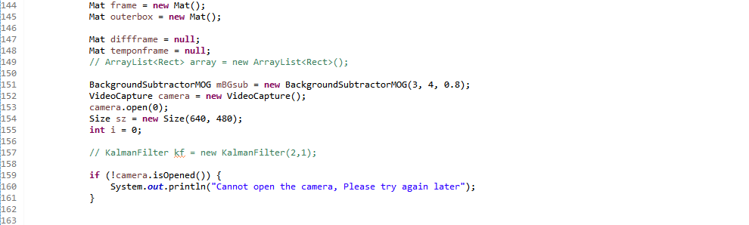
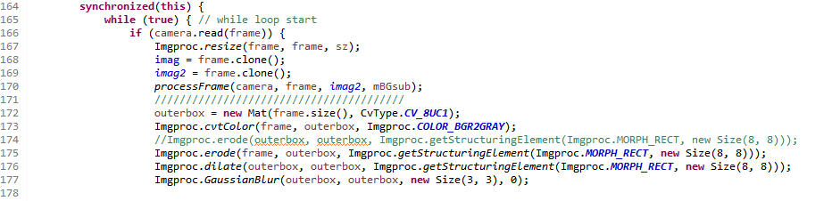
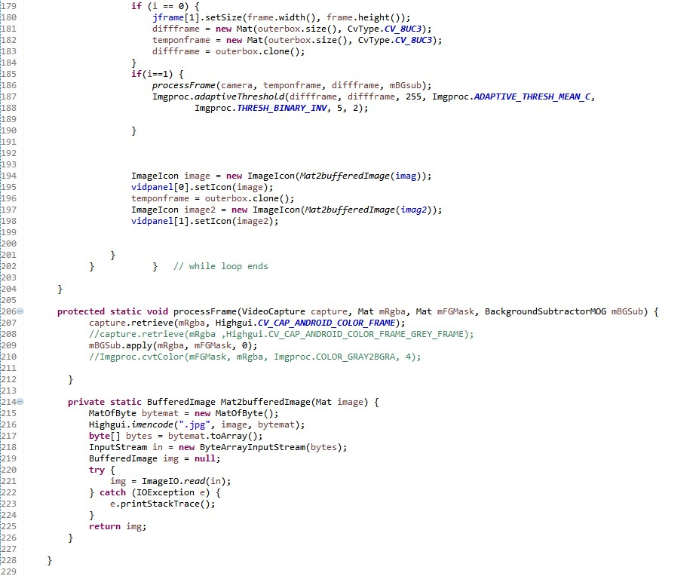

T1.java
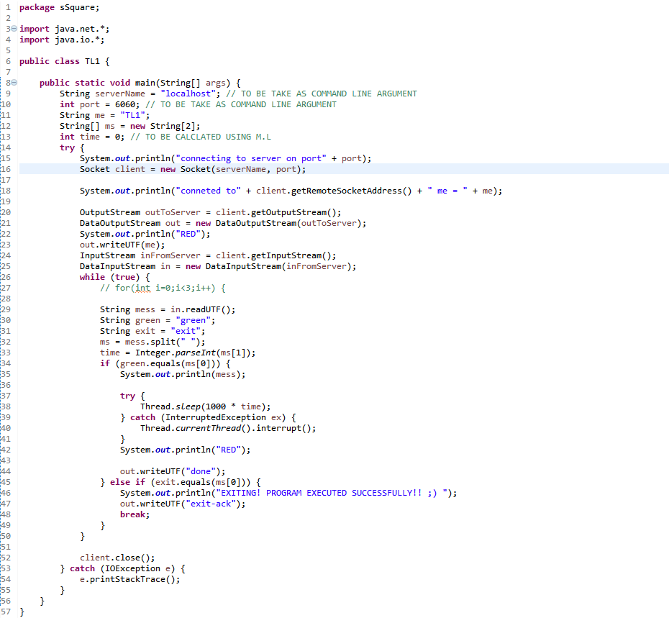

TL2.java
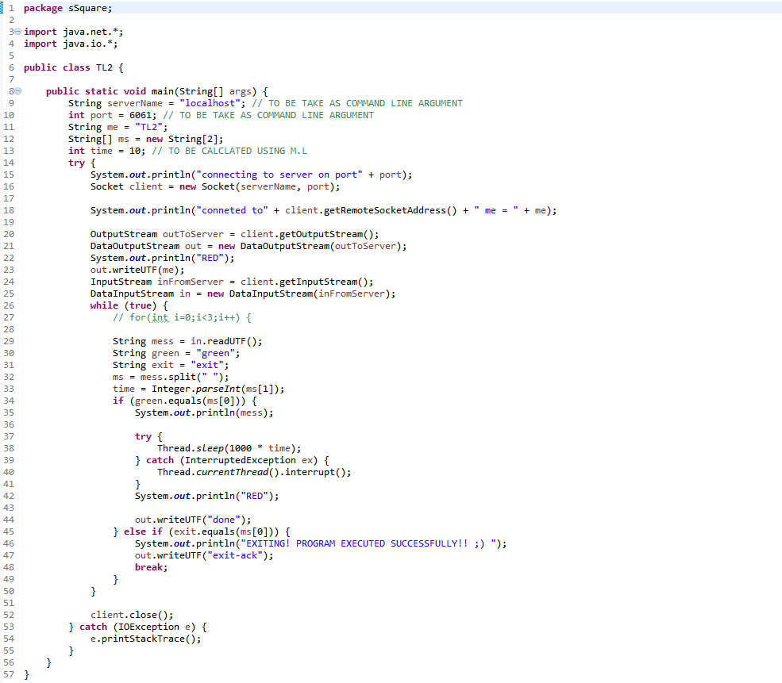

TL3.java
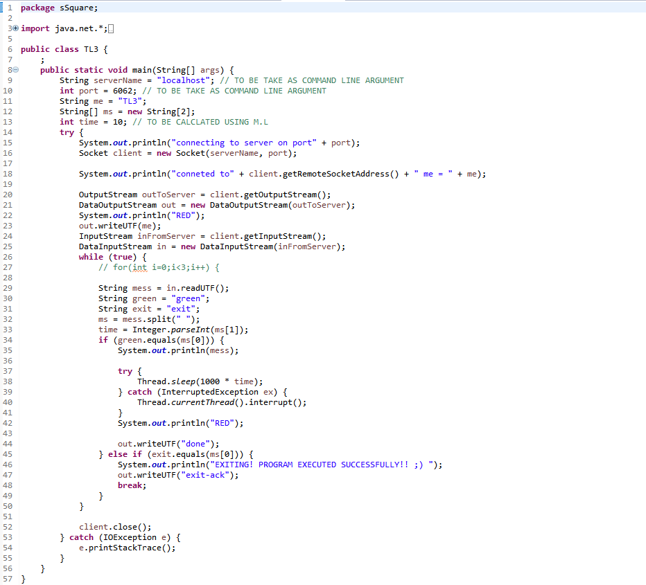

TL4.java
